## Digestive and Urinary Practice test

1. What are the two primary functions of the digestive system?

The diagram below represents the digestive system of a human. It is a simplified version of a real digestive system but clearly shows the major organs making up the systems. Study the diagram and note the position of each organ relative to the others.

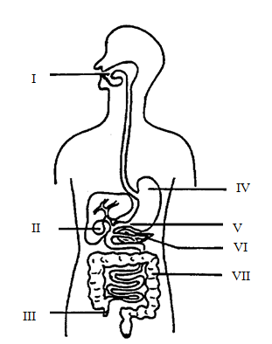

1. Name each of the structures as labelled.
2. What are the primary functions of each of the following structures?

IV:

VII:

1. Name the chemical stored in and secreted by structure (II):

* 1. Explain its function

1. Explain how the chemical stored in structure (VI) aids in the digestive process?

1. By what method does the food being digested move along the digestive tract from structure (I) to the anus?

A type of amylase found in saliva acts on starch. In an experiment a biologist investigated the effect that acidity (pH units) had on the rate of activity of amylase. A number of small, sterilised tubes each containing the same amount of starch and amylase were set up. Each tube had a different pH. The tubes were incubated at 37 degrees celcius and after 30 minutes the relative activity of the enzyme in each tube was measured. The results are shown below.

Tube number pH of Contents Relative activity

1 4.5 7

2 5.0 47

3 5.5 71

4 6.0 84

5 6.5 73

6 7.0 40

7 7.5 7

1. What hypothesis could the biologist have been testing?

1. Plot the data for the pH and relative activity, on separate graph paper.
2. Describe what happens to the relative activity of the enzyme as pH increases.

1. What is the optimum pH for the amylase?

1. What effect would there be if the tubes were incubated at 45 oC? Why?

1. What is an enzyme?

1. Briefly explain how enzyme action is affected by:
2. pH:
3. temperature:
4. The pH of the stomach can vary from 1- 3 due to the secretion of HCl by cells in the stomach wall. Predict what the relative activity would be for amylase if it were placed in the stomach. Use your graph to help your prediction.

1. Explain the role of the Urinary System

1. Fill in the process below for how urine is created
2. Label the diagram below

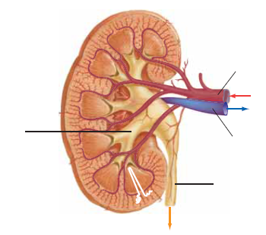

1. Explain the term kidney failure

* 1. What is the first sign of kidney failure

1. Complete the table below comparing dialysis and kidney transplants

|  |  |  |  |
| --- | --- | --- | --- |
|  | What is it? | Advantages | Disadvantages |
| Dialysis |  |  |  |
| Kidney Transplant |  |  |  |